Water Vapor and Alloy Formation
Name of Student
Name of Institution
Date
Maris-Sida, Meier and Pettit sought to understand some fundamental impacts of water vapor during the processes of alloy oxidation, from α-Al₂O₃ (Maris-Sida, Meier, & Pettit, 2003). They found that water vapor in the atmosphere affects high-temperature oxidation of alumina forming coating and alloys. The conditions of water vapor in the air inhibit the development of continuous and adherent alumina scales. The presence of steam also has significant influence in extensive transient oxidation before continuous α-Al₂O₃ forms with comparison to dry atmospheres. The conditions of steam also substantially influence the formation of spinel phase and affects adherence of oxides. Increase in the cation vacancy is as a result of rapid growth of NiO from hydrogen sourced from the water molecules. Consequentially, the conditions bring about the inhibition of the development of α-Al₂O₃ and more transient oxidation. The interfacial toughness of α-Al₂O₃/alloy decreases as a consequence of influence of the water molecules to the adherence of the α-Al₂O₃ scales to alloy substrates. The spinel formation of α-Al₂O₃-gas interface results from diffusion of nickel through α-Al₂O₃. Presence of water vapor provides hydrogen which influences the aluminum vacancy concentration in α-Al₂O₃, therefore, influencing the formation.
Angle, Morgan and Mecartney provided credible information about the diffusion of alumina, and how water vapor enhanced the process (Angle, Morgan, & Mecartney, 2013). The smaller size and lower valence of the hydroxyl ion enhances the mobility of oxygen. Embedded protons impact the oxygen ion through repulsions of the p-electron cloud. The conditiona also favor the polarizaton of the hydroxyl ion, which further facilitates its movement through interstitial sites. The oxygen ions with associated protons that form the hydroxyl ions have a smaller size, flexible hape, and decreased charge, all of which influence faster surface diffusion. The fast rate of diffusion is also relevant to for hydroxyl ions along grain boundaries. There are highly strong bonds of protons withoxygen anions in alumina, which facilitate coupled diffusion of hydroxide. The orotons can hop from the oxygen to the oxygen ion, and quantum tunneling is also a result.
The presence of water vapor where industries use metallic materials under high pressure correlates with power generation petrochemical and aerospace sectors. Power station boilers and heat recovery steam generators are extreme cases where the moisture content is 100%. The combustion of biofuels and fossil fuels produces an atmosphere very rich in water vapor. Critical attention to the impact of water vapor on high-temperature oxidation is a consequential effect of the development of solid oxide fuel cells. The interconnect material must demonstrate resistance to reducing and oxidizing atmosphere, which is both rich in water vapor. Steam is also presented in numerous petrochemical processes within reducing environments. The presence of water vapor is also relevant in the fabrication of vessels of tubes from metallic materials, through the protective oxide layer. Dry oxygen or a mixture of oxygen and steam provides the oxidizing environment of silica from the oxidation of silicon. Previous historical records show no meaning in addressing the influence of water vapor on the rate of reaction and resultant microstructure for experiments with 3% moisture content — additionally, a basis of control by H2/H2O mixtures on oxide compounds. The paper studies the kinetics involved in the growth of oxide compounds within an environment with vapor. Te focus will be on alumina, chromia, silica, and influence of water vapor on titanium and its alloys and oxides of iron and nickel.
- Kinetic effects
- Alumina
The reports on the influence of water vapor on alumina forming alloys are contradictory. A wide-ranging review in 1994 found less than a significant impact in oxidation. However, the results also indicated magnesium dopes aluminas had hydrogen defects, and water vapor reduced scale adhesion. Vapor encourages the formation of hexagonal oxides, with a similar structure to α-Al2O3, which eventually forms. Dry oxygen, on the other hand, initially forms cubic ϒ-Al2O3. The hexagonal alumina has traces of Fe and Cr, which demonstrated lower protection than α-alumina developed in the environments free from the vapor. Water vapor encouraged enhanced gaseous support, therefore leading to the early formation of a stable, protective layer. The creation eliminated any differences in composition and oxide microstructure, with Al depletion leading to breakaway. Hydrated alumina may have formed in the early stages of growth in the wet atmosphere, which was more susceptible to cracking, and this led to an increase in nodule formation.
0.30
P(H2O) = 101325 Pa
P(H2O) = 32500 Pa
P(H2O) = 15000 Pa
T = 1000oC

0.25

0.20
-2
⊗m / S (mg cm )

0.15

0.10

0.05

0.00
0 10 20 30 40 50
t / h
Fig. 1. Weight gain vs. time. water vapour-ratio eﬀect on Kanthal-A1 oxidation at 1000 °C, after Ref. [4].
The influence of water vapor in oxidation at temperatures of 900⁰C is insignificant but reduces scale adhesion. At 700⁰C, vapor promoted internal oxidation and inhibited selective oxidation of alumina. The water molecules present affected the interfacial toughness of the α-Al2O3/ alloy. When cracking and spalling of alumina scales in dry air, water molecules doubled the degradation rate. However, lack of any cracking or spalling limited the influence f water vapor in the oxidation process. During cyclic oxidation, water vapor causes stress corrosion cracking to the Al2O3 alloy. Moisture also reduced interfacial toughness for the alumina/alloy interface, and the presence of impurities exacerbated the effect. An increase in temperature from the range of 680 to 980⁰C required higher critical levels of Al for excellent oxidation.
α-alumina is believed to form in conditions with Fe 14% and 19% Al, with 2% and 5% Cr additions at 500⁰C in 2% O2, 15% CO2 balance N2, with or without the addition of 6% water molecules. The materials with alloy content recorded a significant increase by a factor of 7 from water vapor influence in the oxidation. The presence of water influenced all alloys in the presence of sulphidizing environments. A thin CVD-aluminide coating applied to a 304 stainless steel for short term cyclic tests at 700 and 800⁰C made the alloys more resistant to attacks. The presence of water vapor presented the more severe chance of attack for NiCrAlY plasma sprayed coating in cyclic oxidation tests at 1050⁰C in O2 and O2 + 5% H20. Dry atmosphere led to the formation of α-alumina, while the presence of water vapor formed a mixture of chromia, spinel, and nickel oxides.
The rate of oxidation for alumina-forming MCr AlY coating was higher in hydrogen and steamed gaseous mixes by 25% compared to the dry air at 1080 and 1100 ⁰C. Water vapor at 30% did not affect the oxidation rate of alumina, forming TiAl (CrAg) alloys containing more than 1% Ag in the air at 900⁰C. However, protective α-alumina formed in both cases. For the oxidation of Fe 20% Cr 10% Al at 920⁰C, the presence of only water vapor in the environment provided oxides more abundant in aluminum than compounds with oxygen or oxygen water vapor mixtures.
The kinetics of the formation of alumina is thus not significantly affected, though the presence of water vapor reduces scale adhesion. The presence of water vapor led to the failed development of the alumina layer and increased the rate of oxidation significantly for MCrAlY. The presence of steam has paramount significance in the initial stages of oxidation. It influences the stability of the transitioning alumina, as opposed to controlling transport processes for protective α-alumina post establishment of a layer. The procedures, however, did not present any effect of increasing the water vapor concentration in any setup. It is crucial to forming protective α-alumina scales in dry conditions, then assessing the alteration of water vapor on reaction rate and scale adhesion.
- Chromia
- Chromium metal
Water vapor only slightly increases the growth rate of pure chromium metal. Under characteristics of 800 to 1000 ⁰C, the oxidation rate was 15% higher with 1000Pa addition of water vapor to argon/oxygen mixtures. However, the rate reduced by 60% when water vapor was present in nitrogen/oxygen mixtures. The observations illustrate the reduced influence of water vapor in competitive adsorption when the carrier gas was nitrogen. Though presents ion small amounts, water vapor was the source of the oxidants, but their lack of influence in the oxidation rates signify an insignificant effect on the transportation process. The absence of water vapor brought about cracking for N2/O2 gaseous mixtures since steam made the scale more plastic. The adhesion scale also improved if formed in atmospheres containing water vapor. The results are attributed to the higher fraction scale growing at the metal/oxide interface. Higher hydrogen content is metals also results in increased rates in the presence of water vapor, due to the smaller ionic radius of the OH- (95pm) compared with the 02- (140pm). Water vapor presence also significantly improved scale adhesion in reducing environments. Oxide growth is sustained by the diffusion of chromium and adsorption of water molecules on oxide exposed to low oxygen activity gas, which led to the formation of hydroxyl species. At high oxygen activities, molecular oxygen adsorbs preferentially on the entire surface, overwhelming any local variation due to its catalysis of water dissociation. The context explains the absence of whiskers in the high oxygen atmospheres.
- Chromia forming alloys
Water vapor has a major eﬀect on the oxidation rate of chromia-forming alloys and is most evident for the iron-based alloys. Oxidation for the iron chromium-containing allows are increased with the addition of water vapor into the atmosphere. The failure of the protective chromia layer brings about an increased rate by more than a magnitude after observing an initial period of protection, and a base layer offers subsequent protection. High oxygen partial pressures led to the formation of volatile hydroxides, which caused the failure of the chromia layer. Fe(OH)2 forms at low metal oxide in the inner layers of the scale, which is then converted to haematite and magnetite in the outer layers, which contributes to the higher rates of oxidation. The first stage of breakaway corresponds to the separation of chromia scale from the alloy and consequent scale equilibration, thus allowing the formation of haematite at the metal-oxide interface. The condition is favorable since haematite is more acidic as compared to chromia, and therefore encourages rapid dissociation of water. In the absence of water vapor, chromia formation would continue, and protection maintained.
Hydrogen/water dissociation also increases the rate of oxidation in the pores of the wu stite layer, which is not stable at 1% presence of steam. Increased oxidation could also be a consequence of nickel particles found in the thick scale formed on 316L stainless steel during breakaway oxidation in an air 10% water vapor gas mixture at 1030 °C catalyzed the decomposition of water. Different oxidation processes for iron and chromium alloys reflects their use in the interconnect material for SOFC or in power stations as boiler tube material. Hydrogen generated on one side of the alloy diffuses to the side with a higher pO2 and in doing so, changes the transport processes of the protective chromia to promote more rapid diﬀusion of iron and thus accelerate attack. By applying a coating of the same material with a columnar grain structure with a diameter of about 12 nm, no breakaway was observed after 25 h at 900 °C. The rapid supply of chromium by grain boundary diﬀusion is responsible for the improved behavior, although eventually this would become depleted. Thicker coatings are necessary. Long-term stability of the nanostructured surface is claimed due to pinning the columnar grains to the substrate alloy, and they have an outer layer.
The failure of protective chromia for iron with 15% and 20% chromium at 900-1000⁰C in the atmosphere containing up to 20% water vapor is as a result of cracking. The process admits the water vapor into the alloy/scale interface, prompting a reaction with the ally forming iron oxide and hydrogen. The H2 reduces the chromia, and chromite is the result of reaction with haematite. The presence of layered ceria surface prevented breakaway in the air/water vapor gaseous mixtures, which disregards volatilization as the mechanism. Increasing amounts of water vapor in the atmosphere the time to the onset of breakaway oxidation was reduced but that the rate of oxidation in the breakaway phase was approximately independent of the water vapor content of the atmosphere. Transport processes for chromia-forming alloys within the scale are altered by water vapor, causing relatively small changes in the oxidation rate. Pure chromium metal increase in oxidation emanates from the presence of water vapor, reducing the ability of the alloy to form a protective scale, and since the base alloy controls the oxidation.
- Silica
Oxidation of silicon is widely acknowledged to provide a solid basis for understanding the formation of silica in dry and wet atmospheres. At small thicknesses, the rate is approximately linear, and at the high thickness, it is parabolic. The direct rate results from the interfacial reaction, Si–Si bond breaking, and the parabolic rate is due to diﬀusion controlled processes. Both parabolic and linear rate constants are more than an order of magnitude higher in wet than dry oxygen in the range 920–1200 °C. The main diﬀusing species in dry conditions is molecular oxygen, whereas, in wet conditions, it is molecular water. For very thin oxides, the oxidation rate at 800 °C increases with increasing water vapor content, and the initial model can be improved by consideration of the presence of micropores. In wet gas, the constant rate is proportional to the equilibrium concentration of molecular water which is three orders of magnitude higher than oxygen
Deviations from Deal–Grove are found for the first tens of atomic layers of oxide, which are critical for the ultra-thin oxide layers now demanded. The nature of the oxide closest to the Si substrate is different both in defects and structure from the amorphous stoichiometric oxide further out. Finally, the charge states of both fixed and mobile species are not the same as in thicker oxides films. Under these conditions, the reaction of silica with water vapor to form the volatile hydroxide plays a vital role in the acceleration of the oxidation process. Silicon was most eﬀective in reducing the oxidation rate at the highest temperature tested and at the highest silicon content, where rates were reduced to 50% of that observed with the low Si alloy
Typically, for SiC, oxidation rates were about an order of magnitude higher in O2/90% H2O at 1400 °C than those found under dry conditions, and the rate constant shows a power-law dependence both species are involved in the growth of amorphous and crystalline silica at 1200 °C and 1400 °C, respectively. At lower temperatures (600 °C and 700 °C) for MoSi2 in oxygen 10% water vapor mixtures, the presence of Mo was found to be beneﬁcial in establishing a protective layer of silica. Differences in the volatility of (MoO2(OH)2) and (MoO3)3 allowed the establishment of a compact protective silica layer sooner in the water vapor containing atmosphere than on dry oxygen. The formation of an amorphous silica inner layer was eﬀective in reducing the oxidation rate of an iron 9%Cr alloy to about half that of essentially Si-free steel. Still, the eﬀect of silicon is less beneficial at lower temperatures. Silica does not contain insulating properties, and therefore not able to prohibit transport through scale.
- Titania
In the temperature range, 650–850 °C, the rate of oxidation was directly proportional to the water vapor content, and parabolic kinetics were observed. Hydrogen was found in the metal after exposure, and there was no change in the conductivity of the oxide, which remained n-type. The increased rate of oxidation result from the incorporation of OH— in the lattice and the more rapid diﬀusion associated with, the smaller ionic radius than the oxide ion is the intermetallic titanium aluminide, although in this case for optimum protection alloys are usually designed to form alumina by additions of Cr and Ag. The oxidation rate of titanium aluminides is increased in moist atmospheres compared with dry conditions for alloys where alumina does not form. The rate of oxidation of Ti 47% Al 1% Cr 1% Si doubled at 700 °C when 10% H2O was present in the air compared with the rate under dry conditions. Exclusive formation of alumina did not occur for this alloy under either set of conditions, but instead, a mixed alumina titania scale formed. The eﬀect of water vapor was to alter the morphology and microstructure of the titania. Upon changing conditions from wet to dry air there was an immediate decrease in oxidation rate. Changes in defect chemistry of the rutile resulted in preferential crystal growth and altered morphology of the rutile phase. Hydrogen dissolving in the rutile changed the defect structure and thus, accelerated oxidation. The eﬀect of water vapor was directly related to the composition of the phase(s) present at the metal/scale interface and thus the ability to form a protective alumina scale.
- Iron oxides
At 750 °C, there was no eﬀect of water vapor on the oxidation rate, but that at 950 °C and with the highest concentration of water vapor the rate was increased by a factor of 1.6. The scale had an outer compact layer and an inner porous layer and hydrogen also dissolved in the metal. Increased oxidation in the presence of water vapor was due to a dissociation reaction in the pores of the oxide which contained H2O and H2. The reduction of the oxide occurs at the outer edge of the pore and oxidation of iron ions or metal at the inner surface, thereby transporting oxygen inwards to accelerate the reaction. For this mechanism to operate either hydrogen or water must penetrate the scale and enter the pore. Water penetrated the scale due to the formation of micro-channels. Faster diﬀusion of cations in the grain boundary compared with lattice will cause the grain boundary region to open up. Gas access down the open channel would allow oxidation to occur there and thus close the grain boundary channel. The presence of channels is the result of creep and plastic deformation of the scale. Either proton dissolve in the outer scale and diﬀuse inward to interact with the pore or water is transported through micro-cracks in the scale. Both compact and porous inner layer scales were formed in the oxygen 12% water vapor mixture, whereas oxygen spallation occurred. The compact layers were only found on ﬂat specimens of pure iron whereas porous scales were formed on all specimen shapes of mild steel. Plasticity had been increased by the presence of steam. Hydrogen dissolved in the scale and enhanced plasticity by providing additional sources and sinks for dislocation movement and by increasing the volume of the distorted zone around the dislocation thus permitting easier movement.
- Scales formed on dilute iron alloys
It is widely accepted that the oxidation of dilute iron alloys containing aluminium, chro- mium or silicon in water vapour containing atmospheres is represented by S-shaped curves, which consist of three oxidation stages, the ﬁrst slow, the second rapid, and the third slow oxidation. The ﬁrst slow oxidation produced a thin outer Fe3O4 and Fe2O3 layer, over a thin, protective intermediate layer, consisting of Cr2O3, SiO2, or Al2O3, as well as their complex oxides containing iron. The duration of the ﬁrst slow stage varies, depending on gas composition, temperature, and alloying elements. During the second rapid oxidation, a thick duplex-structure scale formed with an outer Fe2O3, Fe3O4, and FeO layer and an inner layer containing FeO and complex oxides containing Fe and alloying elements. The inner layer is porous, including several small voids. Relatively large voids are found in the outer layer, and these tend to array along the oxide grain boundaries. The third stage of corrosion is characterized by slow oxidation, but the scale structure has not been fully established. The rate of oxidation was dependent on the p(H2O)/p(O2) ratio and a maximum was observed at a ratio of between 5 and 10 the gas mixtures containing increased levels of oxygen a complete layer of Fe2O3 formed and this reduced the oxidation rate.
- Scale morphology
- Whisker formation
Reports for whisker formation are frequent in the presence of water vapor in the atmosphere. The accepted mechanism involves surface diffusion inside a hollow structure that results from the presence of a dislocation in the oxide. The atmosphere containing water vapor has a faster dissociation rate to oxygen, which makes their growth more pronounced. In gaseous mixtures containing carbon dioxide, the facile dissociation of the molecules follows the same mechanism. Te tip of the whisker is a catalyst that promotes the separation of the oxidant. Surface reaction acts as the control for the growth of whiskers, but diffusion controls the rate of scale growth after the thickening of the oxide. Though the influence of water vapor in the kinetics of oxidation for nickel is negligible, modification of the oxide morphology is possible through altering the presence of water vapor.
- Scale porosity
Porous scales are frequently observed when water vapor is present, particularly if there are significant changes in the kinetics of oxidation. The oxidation of pure iron and iron-chromium alloys are good examples of this type of behavior. In the case of iron compounds, porosity is related to the geometry of the specimen for high purity material. Flat surfaces have compact scales while curved surfaces demonstrate porous scales, but mild still did not illustrate any such distinction. The presence of water vapor encourages high rates of oxidation that leads to the formation of pores in iron. Disassociation reactions provide the mechanism for transporting oxidants across the core. New oxide is formed at the metal/oxide side, and oxide dissociates at the oxide/gas side so that the pore moves outward through the scale. The metal/scale interface s a platform for the formation of pores from vacancy condensation for scales and growing cation transport. Enhanced scale plasticity helps maintain contact with the substrate, which consequentially supports oxide growth. The absence of water porosity ensures the loss of communication by the scale with the substrate.
Plasticity or creep deformation explains the voids and grain boundary channels. The absence of water vapor encourages the development of a protective chromium-rich spinel scale, but presence prompts breakaway oxidation. An increase in the thickness scale brings about a decrease in iron activity, which gradually forms haematite on top of the scale. Temperature sets the baseline for further development of the scale. Chromia scales formed in water vapor containing atmospheres also demonstrate porosity, but dry conditions result in metal/scale interface. Vacancy condensation and pore formation depend on the enhancement of chromium diffusion, which is facilitated by an increase in cation vacancies.
- 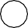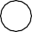
t1
t₂
- 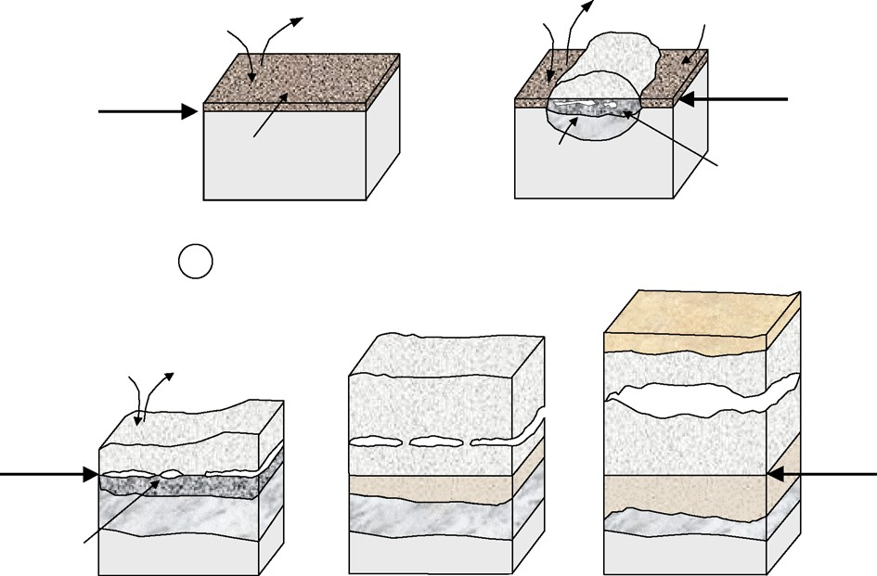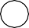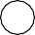
H2
H2O
H2
H2O
protective spinel
alloy surface
Fe3O4
alloy surface
protective spinel
Alloy
FeO + Cr O
2 3
Alloy
Fe3O4 +
Cr2O3
t3
t4
t5

Fe2O3
H2O
H
2
orginal alloy surface
Fe O
Fe3O4
3 4
Fe O
3 4
orginal alloy surface
Fe3O4 + (Fe, Cr)3O4 FeO + Cr2O3
Alloy
Fe3O4 + (Fe, Cr)3O4
Fe3O4 +
Cr2O3
FeO + Cr2O3
Alloy
FeO + Cr O
2 3
Alloy
- Fig. 7. Schematic illustration showing scale formation of 9–12%Cr steels in Ar–H₂O mixtures in the temperature range 550–650 °C. Exact mechanisms and times depend on steel composition and exposure temperature. In case of 10Cr–Mo–W steel at 650 °C the time t₅ is approximately 2–5 h, after Ref.

- Grain size
Dry N2/O2 mixtures and temperature range of 800 - 1000⁰C are favorable conditions for forming chromia with larger grain size. Higher temperatures make the effect more noticeable, which increases the scale of plasticity in the moist gas mixture to the smaller oxide grain size. The mix of Ar/N2 within the presence of water favor has no discernible impact on the grain size.
- Thermochemistry
- Corrosion product stability
All oxides of iron are stable in an environment of pure steam, independent of the operating pressures. The presence of hydrogen in the gaseous mixtures significantly reduces the metal oxides within the environment. The combination of water vapor with either combustion or reducing gases requires determination of oxide stability to follow partial equilibrium pressures of the exact mix. The context also requires ascertaining the balance of probable hydroxides and oxides within the gas mixture of interest.
- Volatile reaction products
Observed competition between volatilization and growth, the overall rate of metal wastage is adequate to account for the observed kinetics. The rates of evaporation increase in the following order: Al(OH)3 < Si(OH)4 < CrO2(OH)2. Reactions of silica and chromia with the product of water vapor have significant pressures above 800⁰C, while aluminum requires 1400⁰C. In high metal oxide compounds in an atmosphere containing water vapor, loss of chromium is a substantial factor in determining the breakdown of protection for several austenitic steels. In high-pressure, steam is sufficiently volatile that it may be involved in the metal wastage process, but that at atmospheric pressure and 700 °C, the vapor pressure is only about 10—10 atm and thus would not be significant. Cr(OH)3 is the most volatile chromium compound over the entire temperature range.
- Oxide growth processes
Several processes are occurring sequentially and concurrently in oxidation. The methods include adsorption of oxidant, oxide growth when ionic species are involved, dissociation, and diffusion of cations or anions through the growing scale. Unless gases are involved in the diffusion defects of oxides, control the transport of cations and anions. The thermal cycle and growth stress the oxides and creep in either the substrate or the oxide provides a mechanism for release. Creep also requires the processes of diffusion defects. The rate controllers for the growth of oxides include majority carriers. The minority carriers are the control for rate in creep.
- Gas adsorption and dissociation
Diffusion and dissociation are subject to catalytic activities on the surface. Alloying additions and oxide defect structure have the capacity to alter these activities significantly. Metals and oxides differ in the chemisorptions due to involvement of lattice oxygen sites and nature of the surface. Cations interact with electron donor molecules, while oxide ions act as basic site through their interaction with acceptor ions. Lattice oxygen sites can react with acidic molecules or selective oxidation reactions can be promoted. In the latter scenario oxygen is added into the adsorbate as a neutral oxygen atom, resulting in a corresponding reduction in the substrate in the form of electrons which may be free carriers. More often, that leads to localized decrease in the oxidation state of the metal at the surface. The degree of ‘coordinative unsaturation’ describes the extent of non-perfect coordination of the surface, and these unsaturated ions are able to act as acidic and basic adsorption sites, but are also bonded less strongly to the lattice so they can more easily be involved in oxidation/reduction reactions. They may also have different electronic properties, which may encourage oxidation and reducing reactions.
The reactions are also subject to the characteristics of element and compounds. Hydrogen is a non-polar molecule with low polarisability and has a weak donor or acceptor properties. Water has a large dipole moment and lone pair electrons and is therefore a good donor. Adsorption occurs by acid/base process with interaction with metal ions; non-dissociative molecular adsorption also occurs. Carbon monoxide has a small dipole moment and in spite of its lone pair electrons is very weak donor. Carbon dioxide can act as a weak donor or acceptor. Oxygen is a very powerful electron acceptor and can be reduced in several steps. Nitrogen and Argon are generally inert. Additional input for consideration includes the hardness and the softness of acid and bases. Hard acids/hard bases interact strongly with each other.
- Acid-base determination
Iso-electric point or point of zero charge provides grounds for measurement of ambient temperature in acid-base characteristics for variety of surfaces. The former is the pH at which powder does not move when an electric field is applied in a given suspension, while the latter is the pH of a solution at which there is of zero charge. In IEP, surface hydroxyl groups can attract protons through number, species and positioning of ions around them since they are not equally acidic or basic. While using acid–base contact angle titration measurements that titania produced by thermal oxidation has the same IEP as that for TiO₂ powders. In the measurement methods for IEP, characterization is subject to specific application. When the acidic or basic property is of interest, IEP and H_{oMax} are appropriate strategies. The heat adsorption of probe gases and chemical shift are appropriate techniques to employ when the absolute acid/base property is of interest.
Point of zero charge provides means of determination of relative basicity and acidity of oxides. The measurements show a more basic functionality compared to its acidic functionality. A variety of methods are used in the determination of PZC inclusive of intersection, CIP, pH, IEP, and Acousto.
- High Temperature Behavior
In the adsorption of hydrogen, nitrogen, carbon monoxide, and water on oxidized zirconium, zirconium metal and chromium in the temperature range of 400-600⁰C, the dissociation rate of CO varies by a factor of 10⁴. Water has a blocking effect since it decreases the dissociation rate of CO on Cr. The following ranking for the tendency of adsorption at high temperatures is made: N₂ < H₂ < CO < H₂O, which is broad agreement with molecular characteristics. Active surface alter the dissociation rates for oxygen. The rate for dissociation for oxygen are functions of temperature within the range of 200-800⁰C on the metallic and oxide materials. Water dissociation rates decreases with any resultant drop in the oxidation rates, but remains unaffected by the oxide defect structure. Partial dissociation of water into OH and H is faster than oxygen dissociation. There are only few active sites on the surface evident from the very few molecules that participate in oxygen exchange and oxidation viewed from mass spectrometry. The dissociation of oxygen has a higher activation energy on diamond than water, hence water is favored for low temperatures and oxygen dissociation at high temperatures.
Whiskers form at the dislocation in the oxide. Their hollow cores allows for rapid diffusion within them, with the availability of oxidants at the tip limiting their growth. The faster dissociation of whiskers at moist atmospheres is the result of faster dissociation of water molecules than any other oxidant molecules. Whisker formation at lower temperatures associates with the presence of water vapor. Dissociation of any gas molecules is favored by the defects on the surface, thus stoichiometric oxides may be less active. Water vapor reacts more rapidly with acidic oxides, hence setting the precedence that acidity or basicity controls reaction with vapor.
- Lattice diffusion
- Alumina
The alumina scale forms by diffusion of oxygen via grain boundaries and counter diffusion of aluminum, which facilitates formation of a new scale within another one. The process exerts a lot o stress which forces the scale to buckle and eventually spall. Rare earth additions improve the adherence of alumina by changing the transport in the scale such that it is predominantly by diffusion of oxygen inwards. The cation Frenkel process has sufficient high energy that makes it of little significance. However, it is not categorically possible to differentiate between the Schottky and anions Frenkel mechanisms.
Impurities dominate the transport processes for isovalent and aliovalent ions in α-aluminum. Large isovalent ions dissolve the α-aluminum while not causing any significant change in the defect structure, which concentrates the grain boundaries and forms the second phase material. The ions will thus open up the grain boundaries thus effectively altering the transport patterns by provision of diffusion paths that transport the oxygen. Hydrogen dissolves in α-aluminum but much of it is immobile. When hydrogen dissolves, the oxides change to n-type from p-type conductors with mixed electronic ionic conduction. The concentration of hydrogen in the oxide increases with any increment in temperature which saturates the oxides. Proton conduction is observable at temperature ranges of 100-1400⁰C in a range of impurity polycrystalline doped α-aluminum at low metal oxides but not at high. Oxide growth is under the control of grain boundary of oxygen, and in the absence of rare earth conditions, outwards diffusion of aluminum is observed.
- Chromia
The extent of non-stoichiometry in chromia is very small. Chromia formation features follows those of α-aluminum, with the difference being outwards diffusion of chromium holds more significance than the inwards diffusion of oxygen, which facilitates growth of the new oxide in the outer part of the scale. Presence of rare elements improves the oxide adhesion rate as a result of a change in the transport properties. The segregation of rare earth elements to the oxide grain boundary enhances oxide plasticity through the prevention of grain growth. For iron with 15% Cr t 800⁰C, the presence of water vapor also encourages inward growth. The presence of water increases the oxidation rate of chromia formed on pure chromium and ferritic steel. Increase in oxidation rate is as a result of increasing cation vacancy concentration as compensation for increment in the concentration of the hydroxyl effect. Chromia scales on pure chromium formed in atmosphere with constituents of water improved adhesion, and appeared more plastic. The principle influence of water vapor is increasing the concentration of majority of the species, such that it shield its effects on creep rates.
- Silica
The alloys with silica have different transportation processes as compared to alumina and chromia because of their glassy structure from formation at 1000⁰C. the formation of silica follows inwards diffusion, facilitating the transportation of oxygen through the Silica scale. Molecular oxygen forms the principle channel for transportation of oxygenduring formation of silica in an open network. In water containing atmospheres, on the other hand, molecular water as the dominant species results in higher rates oxidation.
- Iron oxides
Wu stite grows by the outward movement of iron. Contrary to other non-stoichiometric oxides, it degree decreases in iron oxides with increasing temperature provided the p(0₂) remains constant. The normal defect structure consists of clusters of iron vacancies. Exposure of iron to moist atmospheres increases the rate of oxidation, particularly under high temperatures, with additional increase in plasticity. The presence of water vapor, thus, effectively increases the transportations of cations and anions. Increase in cation vacancies results in plasticity by dissociative mechanisms or increasing dislocation density and mobility. Magnetite grows with the outward movement of iron, which is a metal deficit oxide. The magnetite prompts the presence of cation vacancies and cations interstitial. Oxygen vacancies influence creep through minority defects in magnetite, with relevant association to iron vacancies. Haematite forms through the inward growth of oxygen, and the vacancies of oxygen are predominant defects.
- Nickel Oxide
The oxide is metal deficient with a relatively small non-stoichiometry. The oxide grows predominantly by outward movement of cations, and bulk lattice transport is the dominant difussion mechanism. At lower temperatures grain boundary cation diffusion occurs. Frequently the oxide has a duplex-structure with a porous inner layer of small equiaxed grains and an outer layer of large columnar grains. This inner layer grows by inward migration of gaseous oxygen down grain boundaries and or micro-cracks in the oxide are formed due to build up of oxide growth stress. The more impure the nickel the greater is the extent of inner layer.
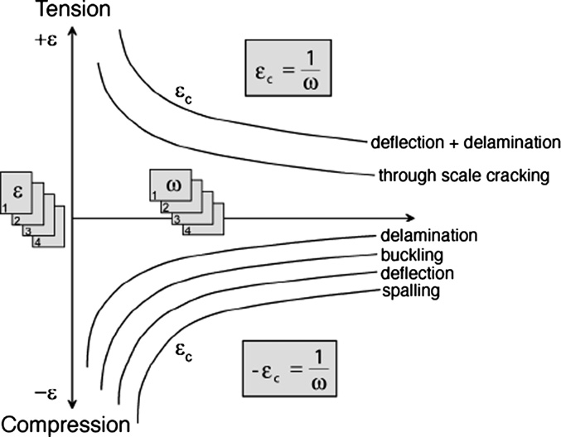
Fig. 24. The next generation EPRI diagram, after [159].
- Molecular diffusion
The most well accepted process for vapor or gaseous transport not directly involving fissures is the dissociative mechanism. This mechanism is only applicable for scales growing by cation transport and involves interaction with voids formed by vacancy condensation that if a void contains both hydrogen and water vapor, oxidation of the surface nearest the metal will occur by reaction with water to form new oxide and the reaction product hydrogen, while a reduction reaction occurs at the surface of the void nearest the gas phase to produce water vapor. The process provides for rapid inward diffusion of oxygen while the void gradually moves outwards from the metal/oxide interface to the oxide/gas interface. One mechanism for pore generation in an Fe - 9%Cr steel is by the reaction of water vapor with magnetite at low p(O₂) near the scale alloy interface to form the volatile Fe(OH)₂. The reaction of oxide with water vapor to produce Fe(OH)₂ develops the porous structure in the magnetite scale.
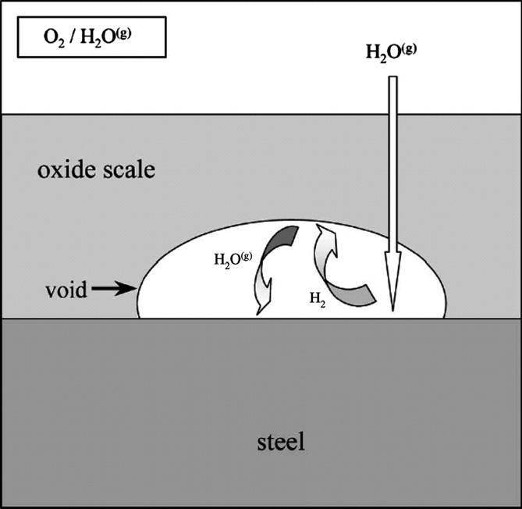

Fig. 21. Schematic illustration showing transport of water vapour molecules through the scale and oxygen transfer across in-scale voids based on the Rahmel Tobolski mechanism [69], after ref [36].

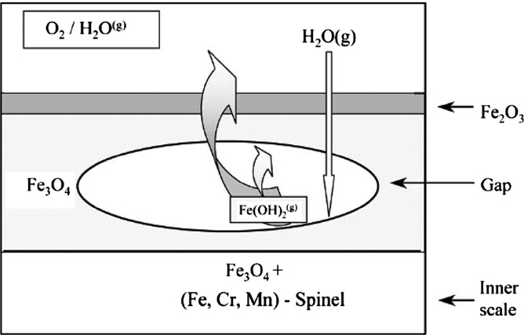
Fig. 22. Schematic illustration showing a proposed mechanism for void generation and transport of iron from the inner to the outer part of the scale formed on a Fe · 9%Cr steel in N₂/1%O₂/2% water vapour at 650 °C, after Ref. [36].
- Stress relief
The processes involved in stress relief can occur through either cracking of the oxide of creep of the substrate. The relative creep rates make the assessment of which between the substrate or the oxide is dominant. Other than a number of iron oxides, metallic materials have demonstrated higher creep rates as compared to oxides. Diffusion creep occurs at homologous temperatures in excess of 0.7 of the melting point, and is significant in deformation of the oxide, together with dislocation.
Table 5
Homologous temperatures of some common oxides and metallic materials
 | Melting point (°C) | Melting point (K) | 0.4T_{m} (K) | 0.4T_{m} (°C) | 0.7T_{m} (K) | 0.7T_{m} (°C)
FeO | 1370.0 | 1643.2 | 657.3 | 384.1 | 1150.2 | 877.1
Fe₂O₃ | 1565.0 | 1838.2 | 735.3 | 462.1 | 1286.7 | 1013.6
Fe₃O₄ | 1594.0 | 1867.2 | 746.9 | 473.7 | 1307.0 | 1033.9
NiO | 1960.0 | 2233.2 | 893.3 | 620.1 | 1563.2 | 1290.1
Cr₂O₃ | 2450.0 | 2723.2 | 1089.3 | 816.1 | 1906.2 | 1633.1
Al₂O₃ | 2054.0 | 2327.2 | 930.9 | 657.7 | 1629.0 | 1355.9
SiO₂ | 1710.0 | 1983.2 | 793.3 | 520.1 | 1388.2 | 1115.1
Fe | 1535.0 | 1808.2 | 723.3 | 450.1 | 1265.7 | 992.6
310 | 1420.0 | 1693.2 | 677.3 | 404.1 | 1185.2 | 912.1
Ni | 1455.0 | 1728.2 | 691.3 | 418.1 | 1209.7 | 936.6
Nim 75 | 1360.0 | 1633.2 | 653.3 | 380.1 | 1143.2 | 870.1

The temperatures are too low to facilitate the occurrence of diffusion creep during the formation of alumina and chromia scales, though viscous flow is observed. Iron oxides have relatively low homologous temperatures and thus diffusion creep is possible at temperatures above 900⁰C. Dislocation creep is a consideration for systems with relatively low homologous temperatures, particularly iron oxides. Creep relaxation is only active while the material is still at high temperature and the oxide is growing. That enable, in most cases when the oxidation temperature is greater than about 700⁰C and for long term oxidation all stresses other than those resulting from thermal transient will be reduced, often to negligible values. Where the oxide cracking is the stress relaxation process, through-thickness scale cracking would result in direct access of the oxidant to the substrate and thus acceleration in the oxidation rate would occur.

References
Angle, J. P., Morgan, P. E., & Mecartney, M. L. (2013). Water Vapor‐Enhanced Diffusion in Alumina. Journal of the American Ceramic Society , 96 (11), 3372-3374.
Maris-Sida, M. C., Meier, G. H., & Pettit, F. S. (2003). Some water vapor effects during the oxidation of alloys that are α-Al 2 O 3 formers. Metallurgical and Materials Transactions , 34 (11), 2609-2619.
Saunders, S. R., Monteiro, M., & Rizzo, F. (2008). The oxidation behaviour of metals and alloys at high temperatures in atmospheres containing water vapour: A review. Progress in materials science , 53 (5), 775-837.

- Appendix
0.30
P(H2O) = 101325 Pa
P(H2O) = 32500 Pa
P(H2O) = 15000 Pa
T = 1000oC

0.25

0.20
-2
⊗m / S (mg cm )

0.15

0.10

0.05

0.00
0 10 20 30 40 50
t / h
Fig. 1. Weight gain vs. time. water vapour-ratio eﬀect on Kanthal-A1 oxidation at 1000 °C, after Ref. [4].

t1
t₂
H2
H2O
H2
H2O
protective spinel
alloy surface
Fe3O4
alloy surface
protective spinel
Alloy
FeO + Cr O
2 3
Alloy
Fe3O4 +
Cr2O3
t3
t4
t5

Fe2O3
H2O
H
2
orginal alloy surface
Fe O
Fe3O4
3 4
Fe O
3 4
orginal alloy surface
Fe3O4 + (Fe, Cr)3O4 FeO + Cr2O3
Alloy
Fe3O4 + (Fe, Cr)3O4
Fe3O4 +
Cr2O3
FeO + Cr2O3
Alloy
FeO + Cr O
2 3
Alloy
Fig. 7. Schematic illustration showing scale formation of 9–12%Cr steels in Ar–H₂O mixtures in the temperature range 550–650 °C. Exact mechanisms and times depend on steel composition and exposure temperature. In case of 10Cr–Mo–W steel at 650 °C the time t₅ is approximately 2–5 h, after Ref.

Fig. 21. Schematic illustration showing transport of water vapour molecules through the scale and oxygen transfer across in-scale voids based on the Rahmel Tobolski mechanism [69], after ref [36].

Fig. 22. Schematic illustration showing a proposed mechanism for void generation and transport of iron from the inner to the outer part of the scale formed on a Fe · 9%Cr steel in N₂/1%O₂/2% water vapour at 650 °C, after Ref. [36].
Fig. 24. The next generation EPRI diagram, after [159].
Table 5
Homologous temperatures of some common oxides and metallic materials
 | Melting point (°C) | Melting point (K) | 0.4T_{m} (K) | 0.4T_{m} (°C) | 0.7T_{m} (K) | 0.7T_{m} (°C)
FeO | 1370.0 | 1643.2 | 657.3 | 384.1 | 1150.2 | 877.1
Fe₂O₃ | 1565.0 | 1838.2 | 735.3 | 462.1 | 1286.7 | 1013.6
Fe₃O₄ | 1594.0 | 1867.2 | 746.9 | 473.7 | 1307.0 | 1033.9
NiO | 1960.0 | 2233.2 | 893.3 | 620.1 | 1563.2 | 1290.1
Cr₂O₃ | 2450.0 | 2723.2 | 1089.3 | 816.1 | 1906.2 | 1633.1
Al₂O₃ | 2054.0 | 2327.2 | 930.9 | 657.7 | 1629.0 | 1355.9
SiO₂ | 1710.0 | 1983.2 | 793.3 | 520.1 | 1388.2 | 1115.1
Fe | 1535.0 | 1808.2 | 723.3 | 450.1 | 1265.7 | 992.6
310 | 1420.0 | 1693.2 | 677.3 | 404.1 | 1185.2 | 912.1
Ni | 1455.0 | 1728.2 | 691.3 | 418.1 | 1209.7 | 936.6
Nim 75 | 1360.0 | 1633.2 | 653.3 | 380.1 | 1143.2 | 870.1

